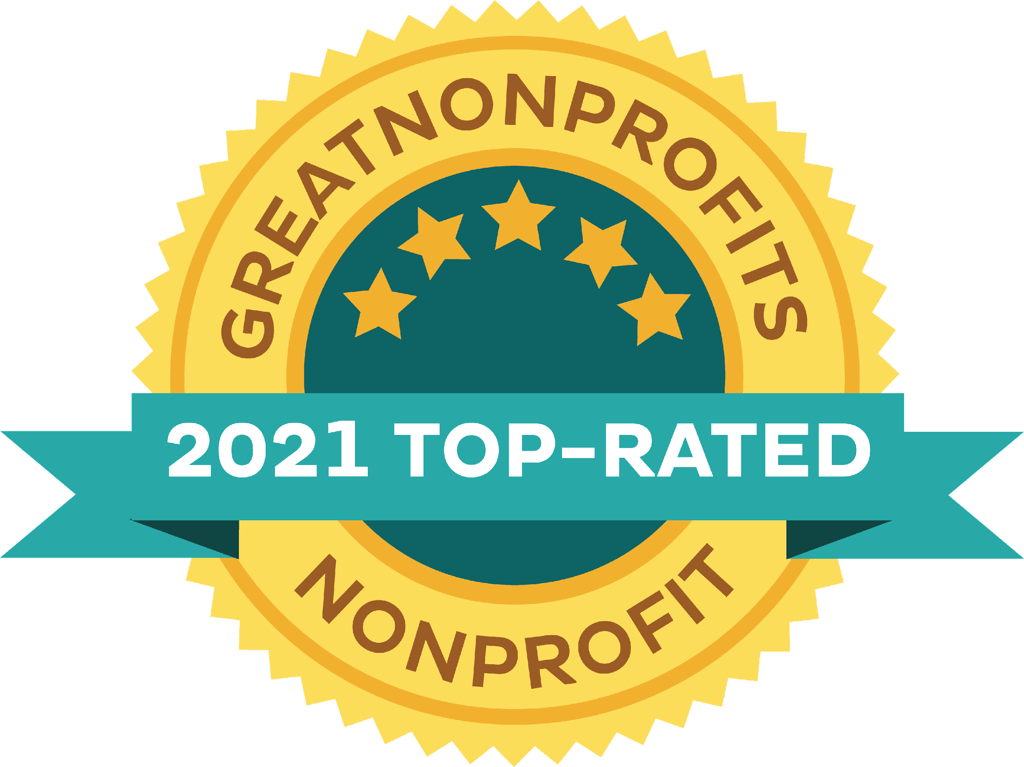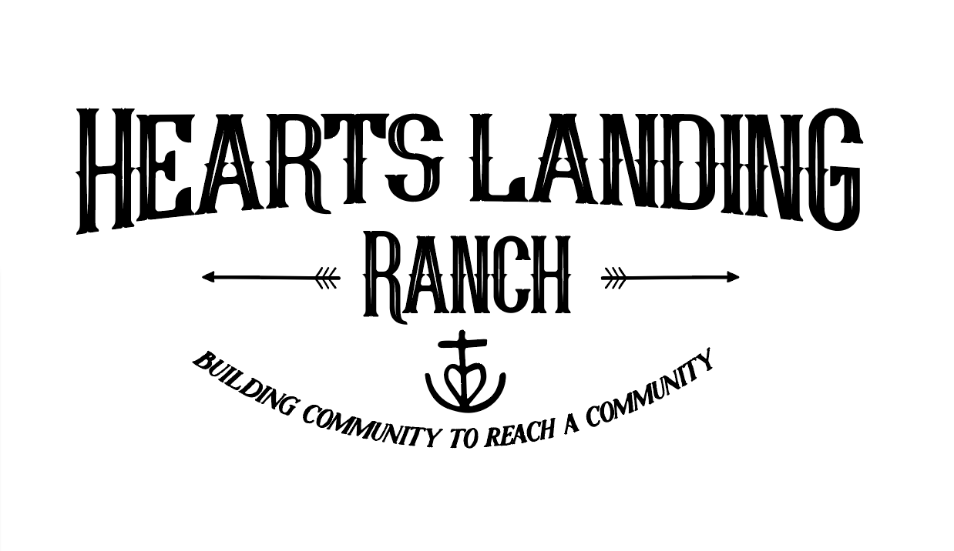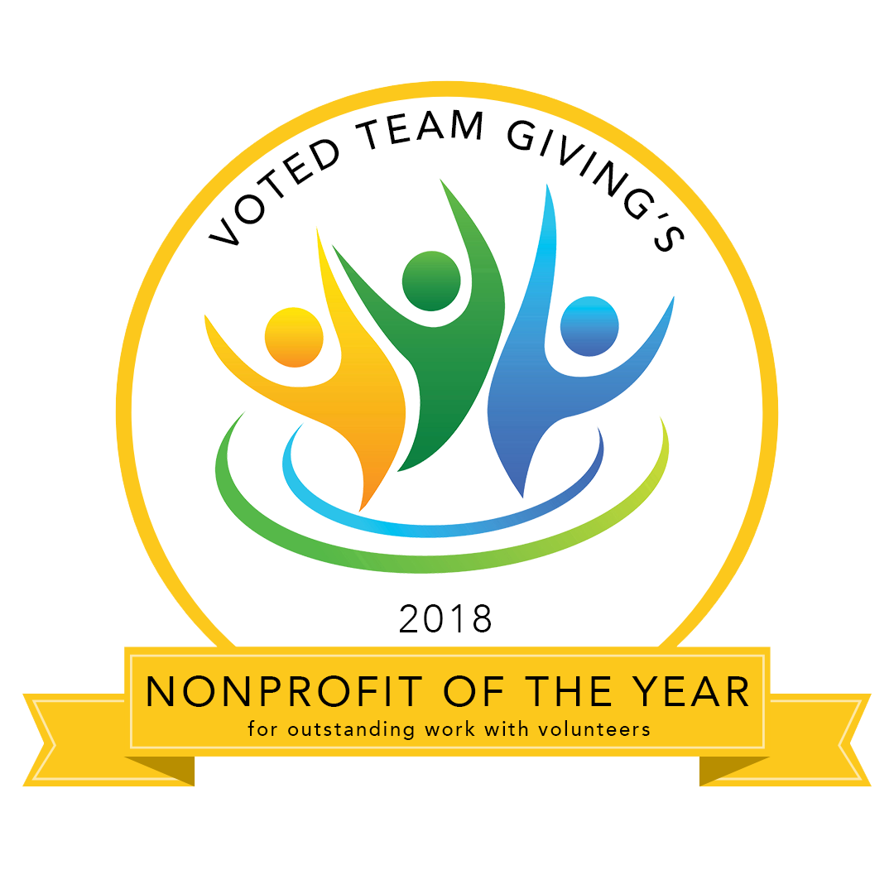
Restoring Lives Thru Rescued Horses

Equine-Assisted Learning or Equine-Assisted Psychotherapy
MINOR SESSION REQUEST FORM

Please be aware Hearts Landing Ranch does not provide transportation. We are located in Granite Bay, approx 20 minutes from Sacramento, CA

How to fill out this form

This is our first glance at your child. We want to hear an honest opinion about them. This means we want the good, bad, AND even unpleasant truths. Our program is here to mentor kids while improving their skills personally, spiritually, socially and emotionally. We encourage you to fill out this form with these things in mind:
- Be HONEST and transparent. Attach pages if necessary.
- Fill out this form completely, don’t leave blanks
- Fill this form out with another individual who knows your child. (Second parent, grandparent, teacher, etc.)
- Talk to and involve your child when filling out the “Tell Us About Your child” section
(They may rate themselves differently)
- If there is anything important we need to know about your child other than what has been asked, please let us know in the very last section*

General Information Date of application: ____________

Child’s Name: ______________________________________ DOB: ________________

Parent(s)/Guardian(s) Name(s): ________________________________________________

Contact’s Email: _____________________________ Contact’s Cell: _________________

Address: __________________________________________________________________

City: ______________________________ State: _________ Zip Code: ________________

School child is currently enrolled in: ______________________________________________

Home Schooled Y/N? If yes, what associate school program? _________________________

School times: _________________ Grade: _____ Age: _______ Gender: _______________

Is your child currently on an IEP or 504 plan? Y/N? If so, please describe: ________________

Does your child have any learning/developmental disabilities? Please describe: ___________ ___________________________________________________________________________

Child is: ____ Foster Child ____ Adopted Child ____ Birth Child

If your child is foster or adopted, at what age did this occur? __________________________

Family:

What is your family’s or child’s religious/spiritual background? __________________________

___________________________________________________________________________

Please describe your child’s family environment and interactions. _______________________

___________________________________________________________________________

___________________________________________________________________________

___________________________________________________________________________

Please list siblings:

Gender: ___________ Age: ______ Currently living at home? ____________________

Gender: ___________ Age: ______ Currently living at home? ____________________

Gender: ___________ Age: ______ Currently living at home? ____________________

If parents are divorced/separated what are the living arrangements for the applying child?

___________________________________________________________________________

___________________________________________________________________________

___________________________________________________________________________

Medical/Mental Health History:
Please share any diagnosis or medications your child has had, or has now:
Rx: _________________ Condition: ___________________ Duration On: _______________
Rx: _________________ Condition: ___________________ Duration On: _______________
Rx: _________________ Condition: ___________________ Duration On: _______________
Prescribing Doctor: ___________________________________________________________
Is your child currently, or has he/she ever been, a danger to themselves or others? Y/N? ____

If yes, please describe: ________________________________________________________

Has your child been in the care of a therapist? ____ Yes ____ No
Therapist: _______________________ Time period seen: ____________________________
I authorize the exchange of Confidential Information with my child/ward(s) medical and mental health contacts provided. *Please also sign the attached ROI form to indicate with whom consent is given.
Signature: __________________________________ Date: __________________

If you were referred, please provide the person’s information so we can thank them:

Name: _______________________ Agency/Company: _______________________________

Phone: _______________________ Email: ________________________________________

About Your Child:

Please describe your child so that we may better understand who he or she is.

____________________________________________________________________________________

____________________________________________________________________________________

____________________________________________________________________________________

Please rate your child in the following areas 1-5 (1 being the least applicable, 3 neutral, 5 most applicable in the specific characteristic)

___Social interaction ___Content ___Team player
___Creative ___Angry ___Authority (does well with)
___Outgoing ___Honest ___Responsible
___Physically active ___Helps others ___Timely completion of chores
___Interaction with animals ___Happy ___Fully completes tasks
___Attentive ___Positive self-esteem ___Detailed oriented
___Academic ___ Depressed ___ Motivated
___Mechanical ___ Anxious ___ Hard working
___Musical ___ Peer pressured ___ Intimidated by others

Programs HLR offers: Please check and mark the area(s) that your child may be interested in.

___ Equine (horses) ___ Horticulture (gardening) ___ Crafting

How did you hear about Hearts Landing Ranch? ____________________________________
Please describe what your goal(s) would be for your child’s time at HLR?

____________________________________________________________________________________

____________________________________________________________________________________

____________________________________________________________________________________

____________________________________________________________________________________

Any other comments or information that would better help us understand your child’s situation?

___________________________________________________________________________

___________________________________________________________________________

___________________________________________________________________________

___________________________________________________________________________

Our Heart and You and Your Child’s Requirements for Participation
The heart of our Equine Session Program is to provide a place for individuals, horses and families to experience hope, healing and encouragement. This is accomplished by inviting individuals to come just as they are and actively engage in the activities
Healing and breakthroughs are possible; expect that it takes time and effort. To start, we like to see clients for 8 weeks, with an assessment at roughly 4 weeks to determine next steps. Mental Health is an invisible wound, and emotions and trauma cannot be seen in the same way as a broken leg. In the same way, sometimes in EAP, “doing the work” doesn’t always feel or look like “doing the work”. Most often, our brains betray us.
We expect that participants want to be here and are willing to work towards their goals. This includes taking personal responsibility for choices, including showing up on time; and barring a health emergency, giving at least 72 hours’ notice of cancellation.

When participants are under 18, we ask a parent/guardian to remain on site while we are in session with your child(ren). There is a designated waiting area, with comfortable seating, near the arena. You also are welcome to wander the large garden (with raised beds, located past the house/driveway) or some people choose to wait in their car. Please respect privacy and do not sit on the paved patio around/next to the house. Please also keep in mind the privacy and concentration of those participating in sessions.

Session Components
Equine Session activities are dependent on treatment goals, and can take many unique forms. The basics, however, will always be the same for an Equine-Assisted Psychotherapy (EAP) Session, which would include an Equine Specialist (ES), a Mental Health Professional (MH) and horse(s).
Equine-Assisted Learning (EAL) may also be available, and would be implemented with a mentor and horse(s), without a mental health specialist. This may be an option, for example, if someone needs to work on life skills such as communication, perseverance, or boundaries.
Working with horses: The majority of participants who come to Hearts Landing Ranch are drawn to the Ranch because of the horses. While some of the Sessions will include learning to correctly handle, groom, wash, round pen and even assist “vet” horses, Session Plans are written with specific goals in mind, including developing personal growth and helping to build a bridge of understanding through the pain or difficulty an individual may be experiencing, not to become an accomplished horseman/horsewoman or rider. If you would like riding or horsemanship specific training, talk to us and we can make a recommendation.
Disclosure and Consent Statements
Statement of Faith
​Hearts Landing Ranch is a faith-based organization. Although the ranch is not associated with any particular denomination, we are founded upon Christian principles and values. It is through Christ Jesus' grace, forgiveness and transformation that we have hope and new life. It is our greatest joy and honor to live out our faith in action by serving children and families of all backgrounds with the same loving grace that has been freely given to us.
Clothing & Equipment Requirements & Recommendations
- Shoes/boots with closed toes and closed heels are required. Leather boots are recommended for greatest protection. (Sometimes, we have extras on hand). No steel-toed boots should be worn for safety reasons.
- Nothing is permitted to be hanging down around the neck or tied around the waist while working around the horses
- Sessions are Rain or Shine. Come prepared. Sacramento weather is HOT in the summer and winter is ever changing; layered clothing is always a good idea.
- We recommend that individuals bring their own hat, water bottle, snacks and sunscreen.
Safety Rules
  - Children may not be unattended.
  - Children may not run or play loudly.
  - Dogs are not allowed to be brought onto Hearts Landing Ranch property.
  - The session areas, barn or horse areas are not open to parents, family members, caregivers or visitors without prior permission.

Possible Reasons for Participant Discharge
  - Fees are not paid as originally agreed.
  - The participant has reached all of his/her goals.
  - The participant misses scheduled appointments without prior cancellation. (You will be charged for the time, if proper notice of 72 hrs is not given).
  - The participant’s inability to follow directions is interfering with progress toward goals.
  - The participant is uncontrolled and/or participates in inappropriate behavior that constitutes a safety risk to him/herself, staff, volunteers, and/or horse(s).

Cost
The cost of an Equine-Assisted Psychotherapy (EAP) session is $175 per person/per session group rate (with a minimum of 3) or $300 for each private session. We are private pay, and can accept credit card, check, Venmo, PayPal, cash or HSA. If you have medical insurance, a portion might be covered through your mental health professional. We are not set up to bill insurance directly. Fees must be paid out of pocket. All those who have insurance to assist with this fee are expected to handle payment for services and bill their insurance company themselves. We are willing to provide receipts needed to do so. It is your responsibility to see that all fees are covered. If you will be filing to your insurance, it is IMPORTANT that you realize that we must assign a diagnosis, and that diagnosis will permanently be on your medical record. We strive to keep the tuition fee as low as possible through vigorous fundraising efforts conducted throughout the year, as well as through the help of scouts, and local businesses and churches who have committed donations, and volunteer hours. Financial assistance in the form of a scholarship is available to a limited degree for those who qualify. Please inquire about the sliding scale if payment is not possible without assistance. Payment in full is required at the beginning of each session, and scholarships must be secured ahead of time. Due to the high level of program activity, we are not able to offer refunds, make-ups for missed sessions, or carry a balance over from one session to the next.
If you are unable to keep your appointment, please give 72 hours notice. Unless there is an extreme emergency, we will charge for your session if 72 hrs of notice is not given. You will be charged the full fee if no notice is given.
If you are in the position to give further, consider planned giving through Mandatory IRA disbursements, Owner Advised Funds, Stock Options and Estate Planning. We encourage you to talk with family and friends who are passionate about giving back. Many companies also match employee donations. Hearts Landing Ranch is an approved Benevity nonprofit.
Confidentiality Policy
Confidentiality is defined as “told in secret or private relations; trusted.” Any information in regards to the participants (clients) at Hearts Landing Ranch must be held in strict confidentiality. It is critical that we respect each individual. Confidentiality is considered one of the most basic responsibilities of our facility. In failure to abide by this policy, the quality of the services we provide may diminish and result in legal ramifications.
I have read and understand Hearts Landing Ranch’s Policy of Confidentiality and agree to abide by the same.
Signature for Confidential Policy: ____________________________________________________________
Social Media Agreement
Hearts Landing Ranch appreciates clients’ enthusiasm in sharing the growth and experiences from being part of this program. However, we ask that you consult with Hearts Landing Program Director before taking any video or pictures of a session, as well as prior to posting sessions online and/or referencing Hearts Landing (including on Facebook, Instagram, YouTube, Twitter, Vine, etc.). For those who do not know our work, some of the therapeutic exercises may be taken out of context. Also, not everyone in our program is open to sharing their personage on social media. I agree to request permission from the Hearts Landing Ranch Program Director before taking personal photos or videos and agree that no pictures or videos may be posted online of any sessions that contain another individual that I may capture or be featured in and/or before referencing Hearts Landing Ranch.
Signature for Social Media Agreement: ______________________________________________________

Thank you for taking the time to thoroughly fill this form out and provide a transparent and complete assessment.

NOTE: Please make sure that the above form is complete. Incomplete forms will only delay the admission process or void it completely. If you have any questions, please feel free to refer to our website www.heartslandingranch.com or call us at 279-529-8279.

Please send completed forms via email to: heartslandingranch@gmail.com

Demographic Data Form
Notice to Applicants - Completion of this Form is Voluntary.
The purpose of this Data Form is to provide statistical data being requested when Heats Landing Ranch applies for grant money…which helps the Ranch provide services to more people. The data you provide on this form will be kept confidential and used solely for statistical purposes. Completion of this form (pages 7 & 8) is optional and voluntary.
Date: _____________________ Minors Name: _______________________________________________
Voluntary Identification of Ethnicity, Race, Age Range, and Gender
Race/Ethnicity: (Please Select One)
- Hispanic or Latino – A person of Cuban, Mexican, Puerto Rican, South or Central American, or other Spanish culture or origin regardless of race;
- White (not Hispanic or Latino) – A person having origins in any of the original peoples of Europe, North Africa, or the Middle East;
- Black or African American (Not Hispanic or Latino) – A person having origins in any of the Black racial groups of Africa;
- Native Hawaiian or Other Pacific Islander (Not Hispanic or Latino) – A person having origins in any of the peoples of Hawaii, Guam, Samoa, or other Pacific Islands;
- Asian (Not Hispanic or Latino) – A person having origins in any of the original peoples of the Far East, Southeast Asia, or the Indian Subcontinent including, for example, Cambodia, China, India, Japan, Korea, Malaysia, Pakistan, the Philippine Islands, Thailand, and Vietnam;
- American Indian or Alaskan Native (Not Hispanic or Latino) – A person having origins in any of the original peoples of North and South America (including Central America), and who maintains tribal affiliation or community recognition; and
- Two or More Races (Not Hispanic or Latino) – All persons who identify with more than one of the above five races.
- Other: (Please specify) _____________________________________________________________

Age range:
- 0-5
- 6-12
- 13-18

Gender:
- Male
- Female
- Transgender
- Decline to state
- Other (please identify): ____________________________________________________________
Child is:
- Foster Child
- Adopted Child
- Birth Child
Voluntary Identification of Education and Employment Status
Level of Education: (Mark all that apply)
- No schooling completed
- Grade School completed through grade ______
- Middle School completed through grade _______
- High School through grade ______
- High School graduate or equivalent (GED)
- Some College credit--no degree
- Trade School Certification: (Please identify) _____________________________________________
- Other: (Please Identify) _____________________________________________________________

Education received through:
- Home School
- Public School
- Private School
- Charter School
- Other (Please Identify):

Employment Status:
- Not Employed
- Employed full time
- Employed part time
- Self-Employed
- Unable to Work

Is the minor Bilingual? Yes No If yes, what language___________________________________________

Signature of Parent/Guardian/Conservator: _________________________________ Date: _________________

THANKS FOR YOUR ASSISTANCE!

Phone: (916) 521-1343
8902 Quail Ln, Granite Bay, CA 95746
Authorization to Release/Receive Information

Client Name:__________________________ Date of Birth: _______________PH#________________

Address: ____________________________________________________________________________

I authorize the exchange of information between:
Hearts Landing Ranch
and
(Name, Ph#, Fax#) ____________________________________________________________________
And
(Name, Ph#, Fax#) ____________________________________________________________________

Duration: The authorization is effective immediately and shall remain in effect for one year from the
authorization date unless otherwise specified: __________________

Information to Be Exchanged:
( ) Mutual exchange of information relevant to assessment, diagnosis and treatment.
( ) Evaluation or Progress Letter
( ) Treatment Summary
( ) Other: ____________________________________________________________________
I have had it explained to me and fully understand this request/authorization to release records and information, including the nature of the records, their contents, and the consequences and implications of their release. This request is entirely voluntary on my part. I understand that I may take back this consent at any time, except to the extent that action based on this consent has already been taken. This consent will expire automatically after one year from the date on which it is signed, or upon fulfillment of the purposes stated above. I acknowledge that I have been offered a copy and may either accept or refuse.
Authorizing Signatures:
Client: ____________________________________________________ Date: ____________________

Parent/Guardian/Conservator: __________________________________ Date: ____________________

Treatment Provider: _________________________________________ Date: _____________________

I have read and understood the Participant documents in their entirety:
____________________________________________________________________________________________________Full Name Signature Date

